**FIM590-001 HW3 Yuan Chun Lin**

**Problem #1 (Implementing Lookback)**

*Based on the Python scripts on the FIM590 Moodle page, implement the VIX multinomial trading signal with a dense neural network and a lookback window of 2, 5, 8 and 10 days. Which length of window works best? Use the following block of code to put your labelled data into lookback form.*

1. *Lookback window of 2 days:*

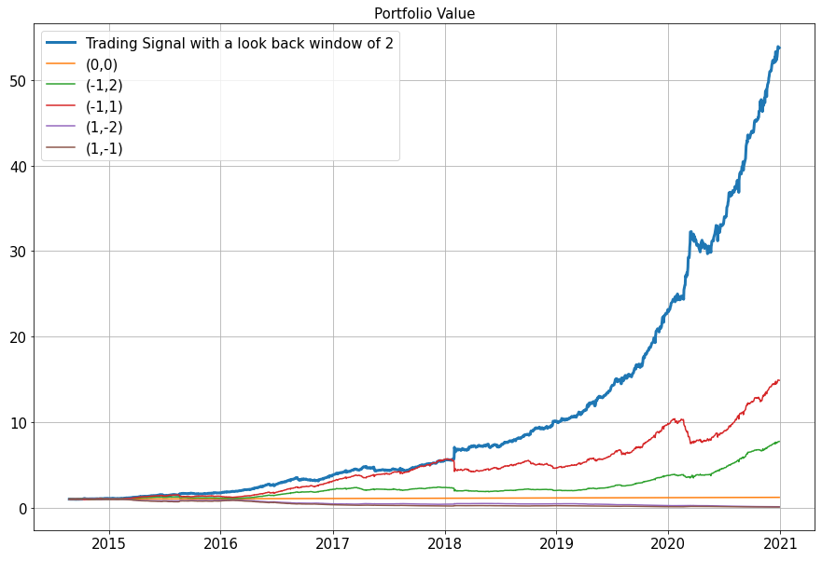

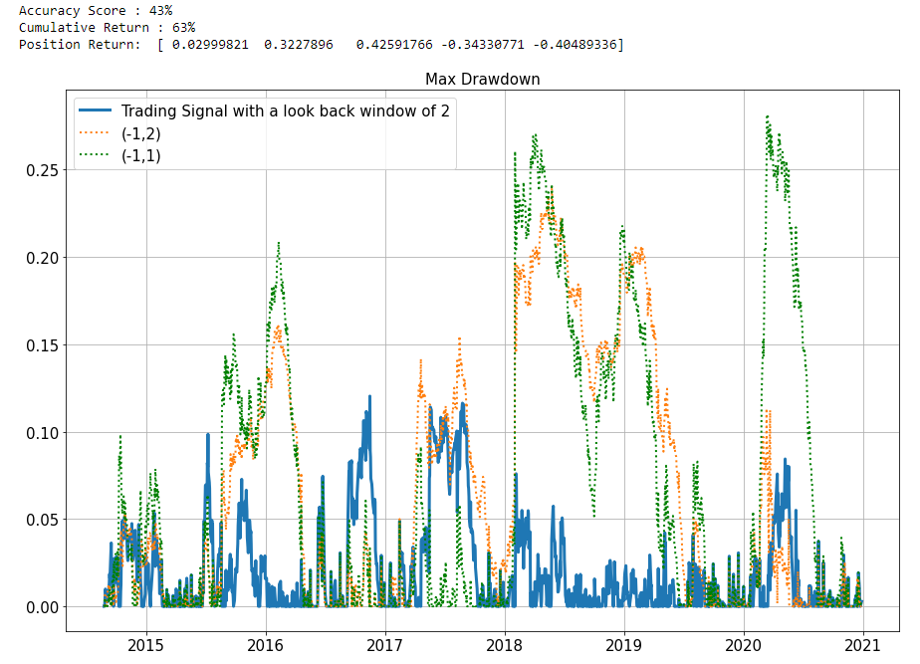

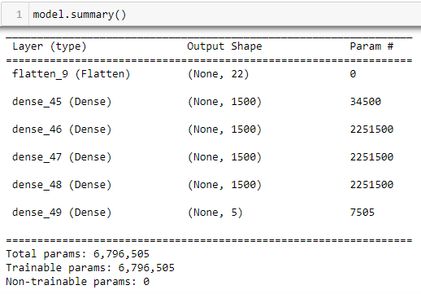

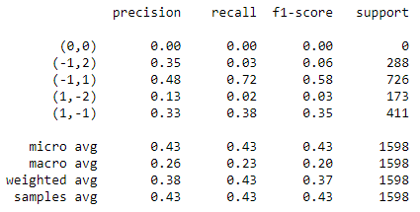

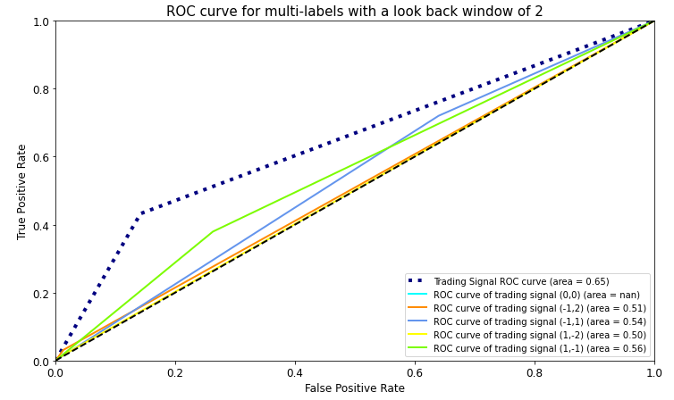

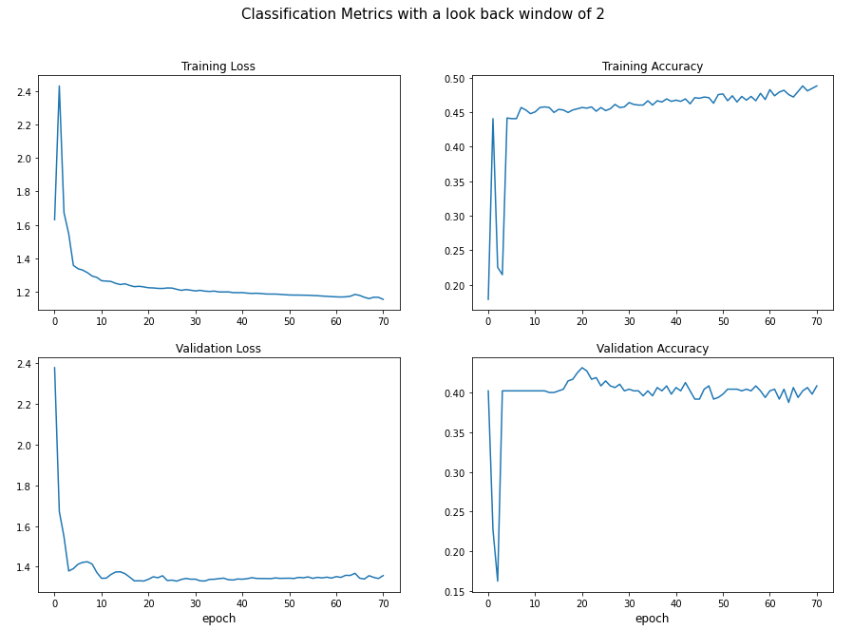

**\*\* We can see the performance indicator for model with lookback window size = 2:**

**1. Accuracy score: 43%**

**2. Cumulative return: 63%**

**3. Max drawdown: lower than others trading strategy**

**4. ROC curve: 0.65**

1. *Lookback window of 5 days:*

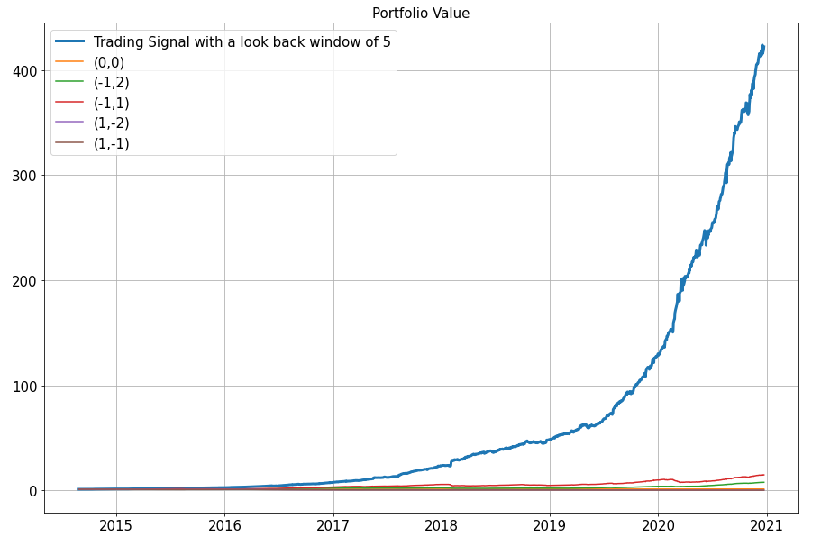

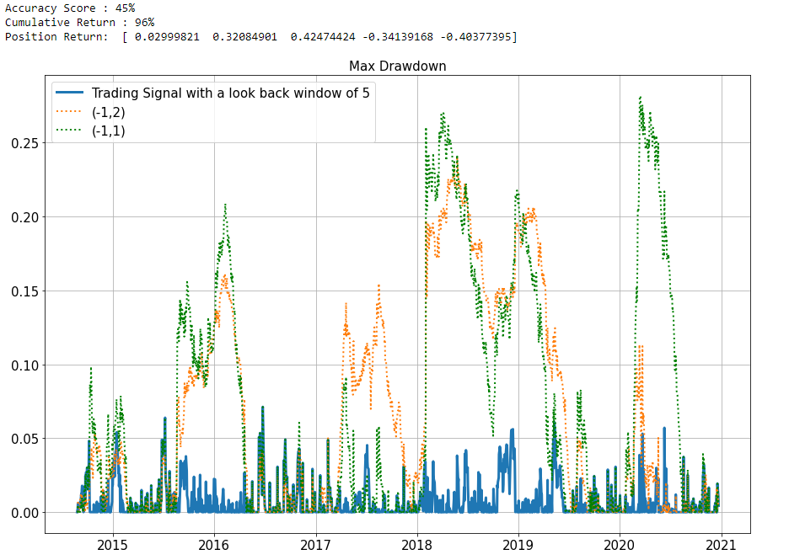

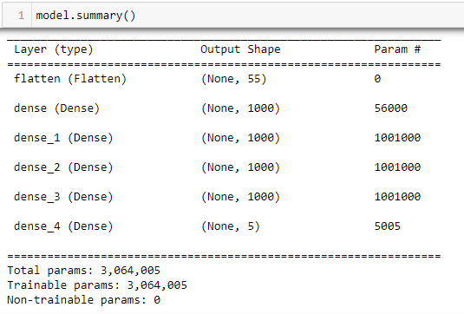

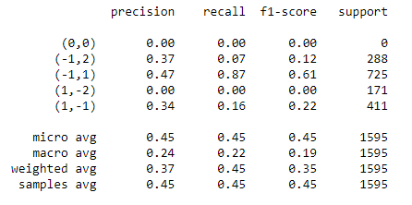

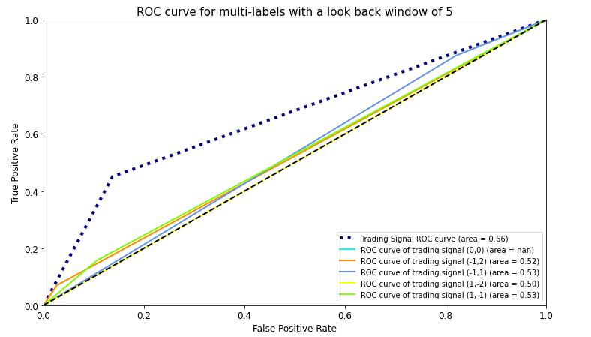

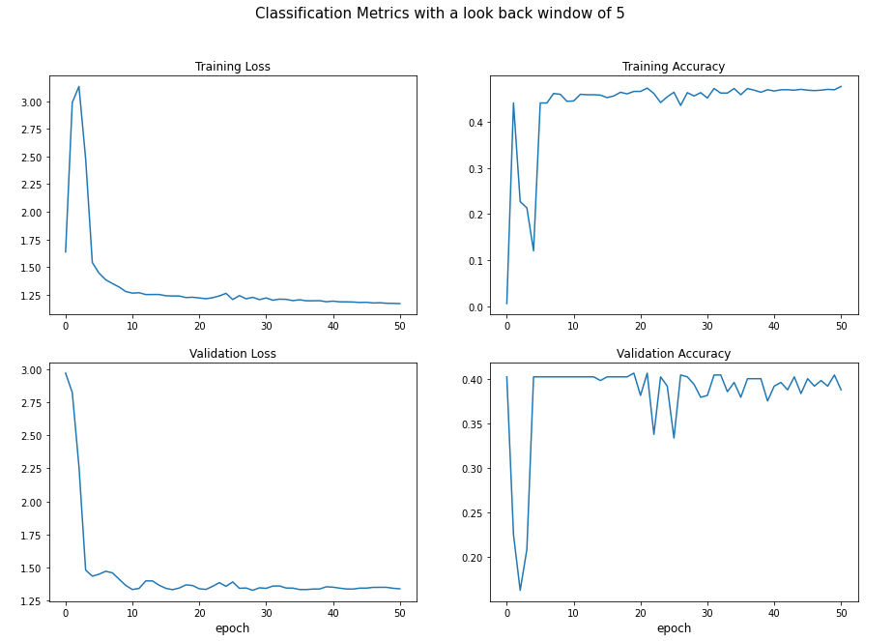

**\*\* We can see the performance indicator for model with lookback window size = 5:**

**1. Accuracy score: 45%**

**2. Cumulative return: 96%**

**3. Max drawdown: lower than others trading strategy**

**4. ROC curve: 0.66**

1. *Lookback window of 8 days:*

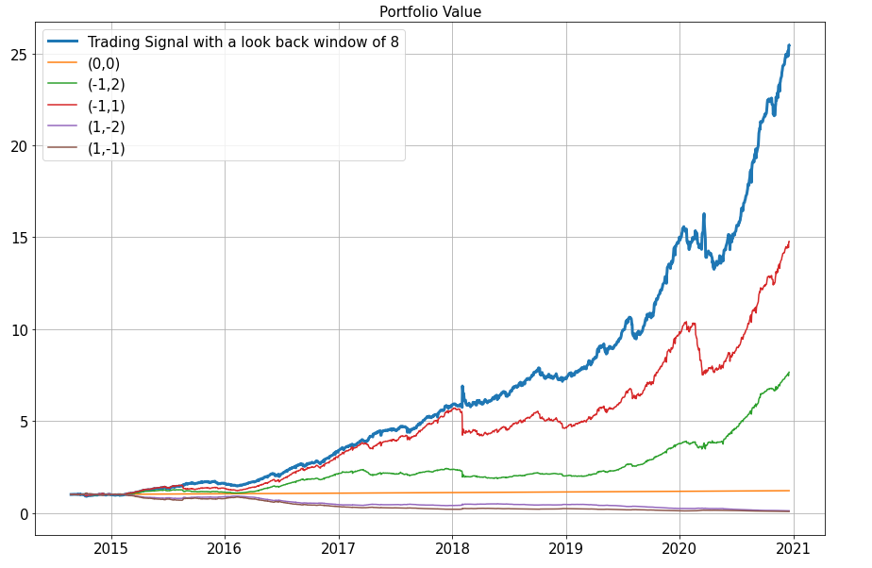

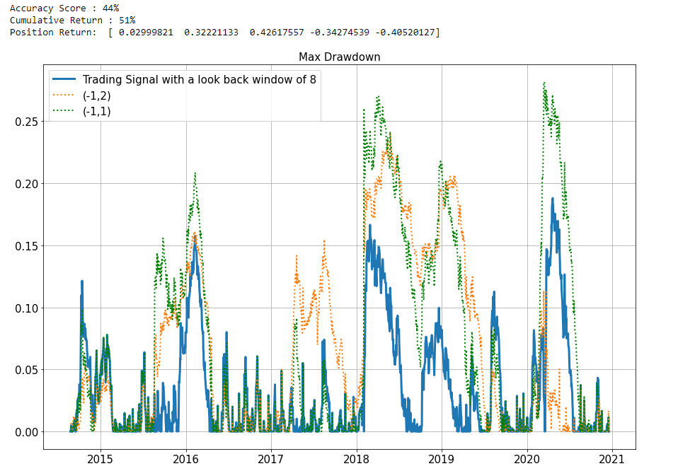

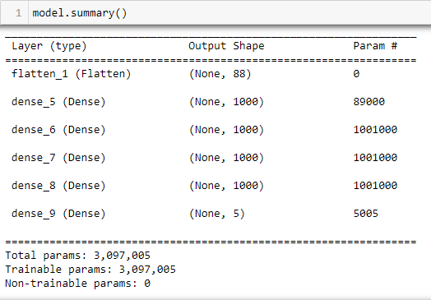

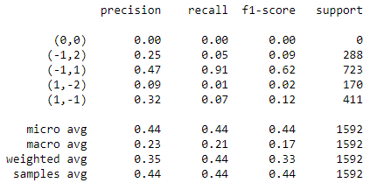

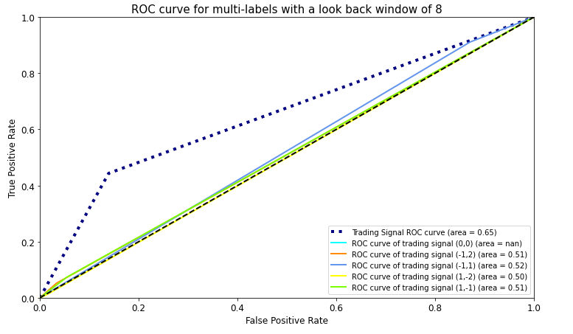

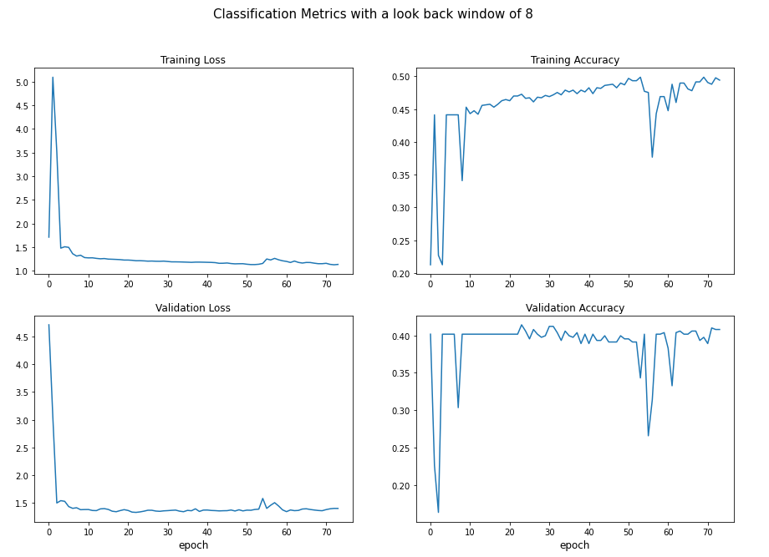

**\*\* We can see the performance indicator for model with lookback window size = 8:**

**1. Accuracy score: 44%**

**2. Cumulative return: 51%**

**3. Max drawdown: lower than other trading strategy, but closed to others.**

**4. ROC curve: 0.65**

1. *Lookback window of 10 days:*

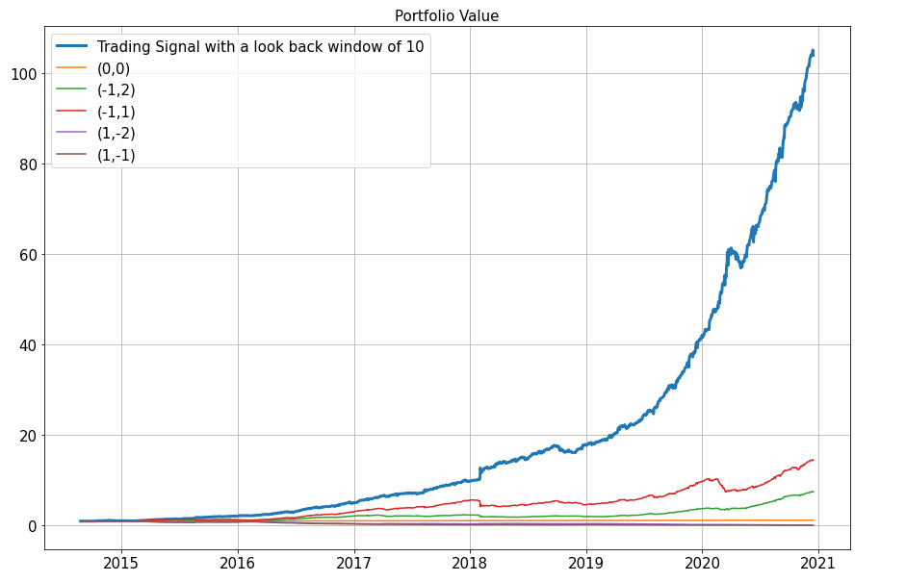

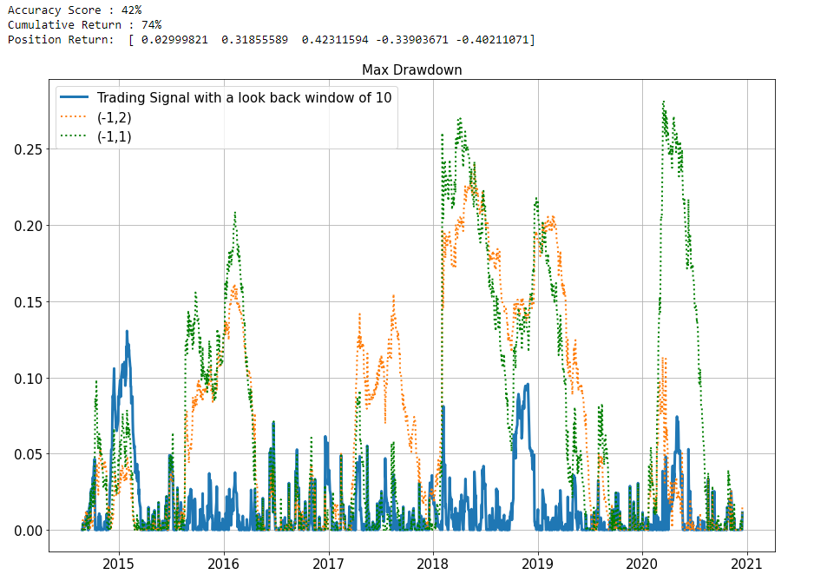

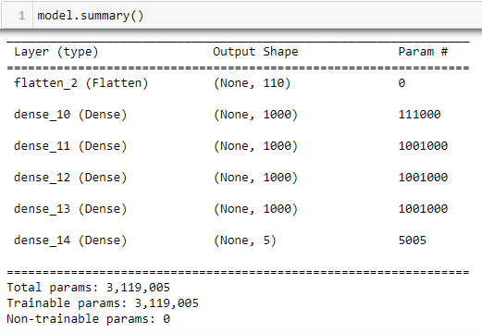

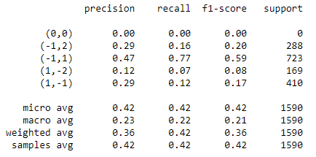

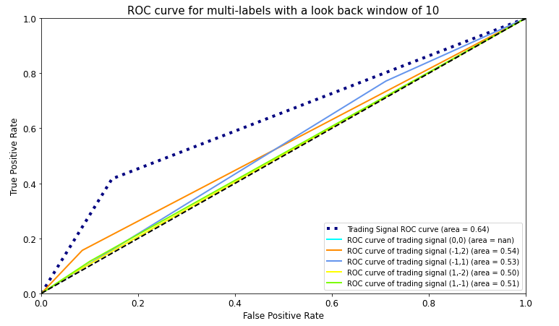

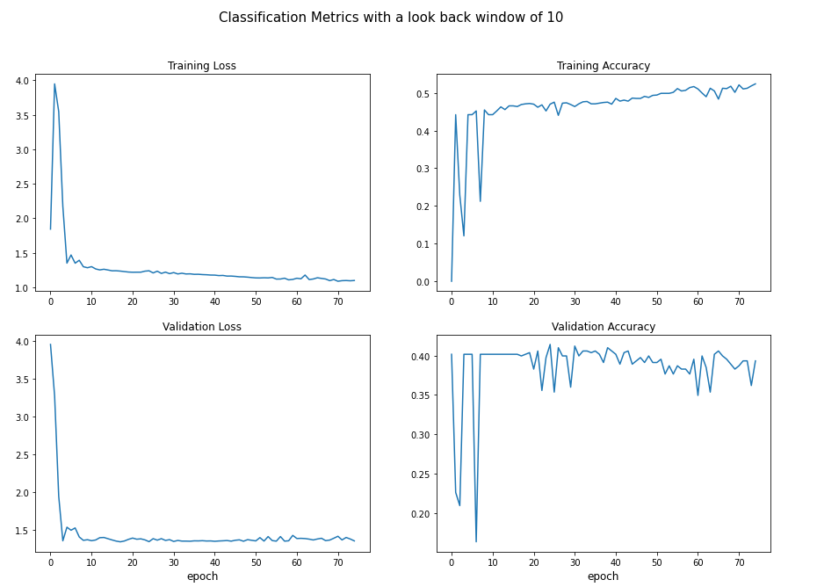

**\*\* We can see the performance indicator for model with lookback window size = 8:**

**1. Accuracy score: 42%**

**2. Cumulative return: 74%**

**3. Max drawdown: lower than other trading strategy, but closed to others.**

**4. ROC curve: 0.64**

**\*\*\* As the conclusion of problem #1, I think the trading signal with lookback window of 5 days is the best strategy. It has the higher accuracy score and annualized cumulative return. We also can see its max drawdown is lower and smoother than others. Besides, ROC curve is doing well. Thus, I think the trading signal with lookback window of 5 days is the best.**

**Problem #2 (Cross Validation of Lookback)**

*Perform a K-fold cross validation for the best lookback window from part #1. Based these cross validations, does the lookback provide improved performance in comparison to the trading signal without lookback?*

**\*\* Based on problem #1, we choose lookback window size = 5 as the best method to perform a K-fold cross validation.**

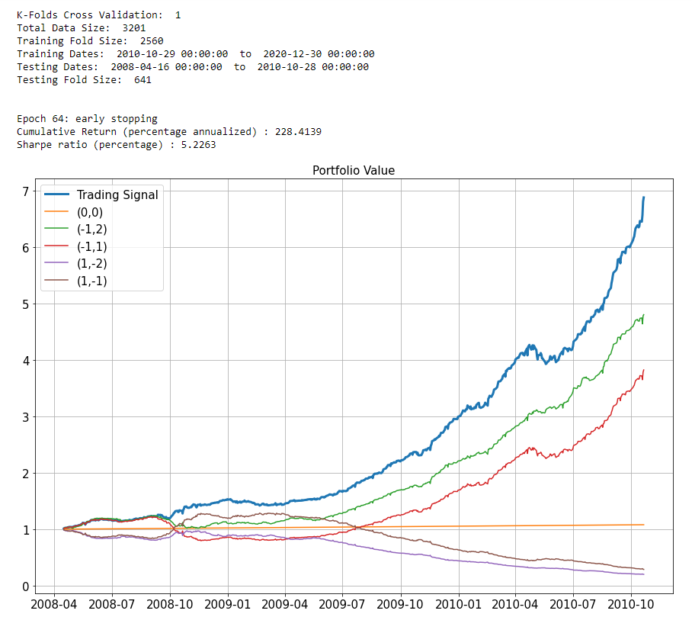

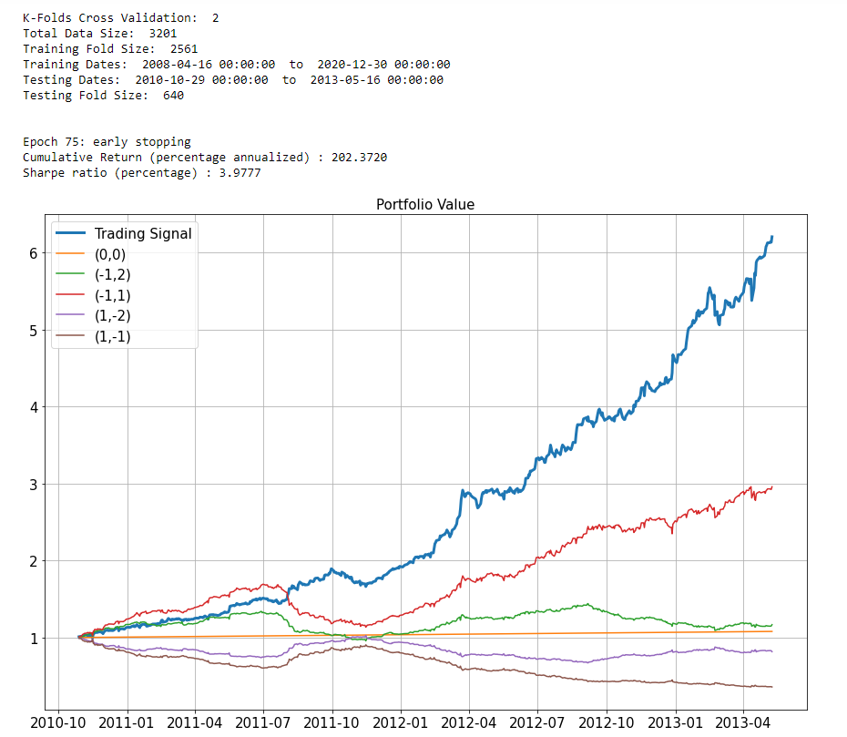

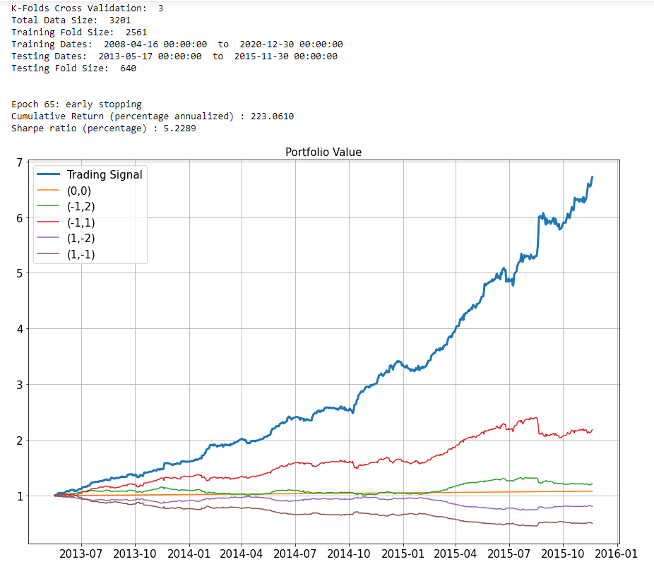

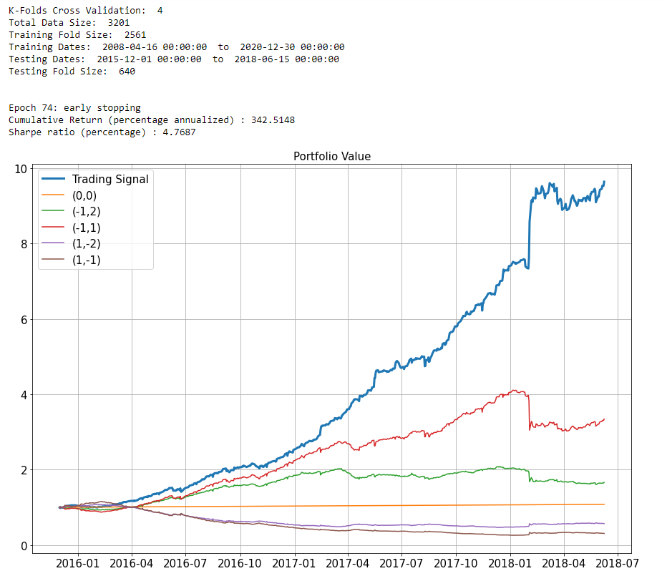

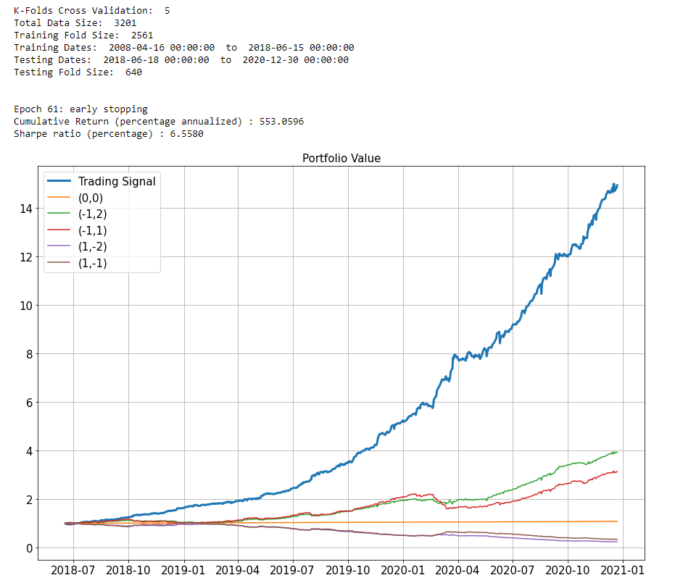

**\*\* We perform a K-fold cross validation without look back window, in order to compare with first part approach.**

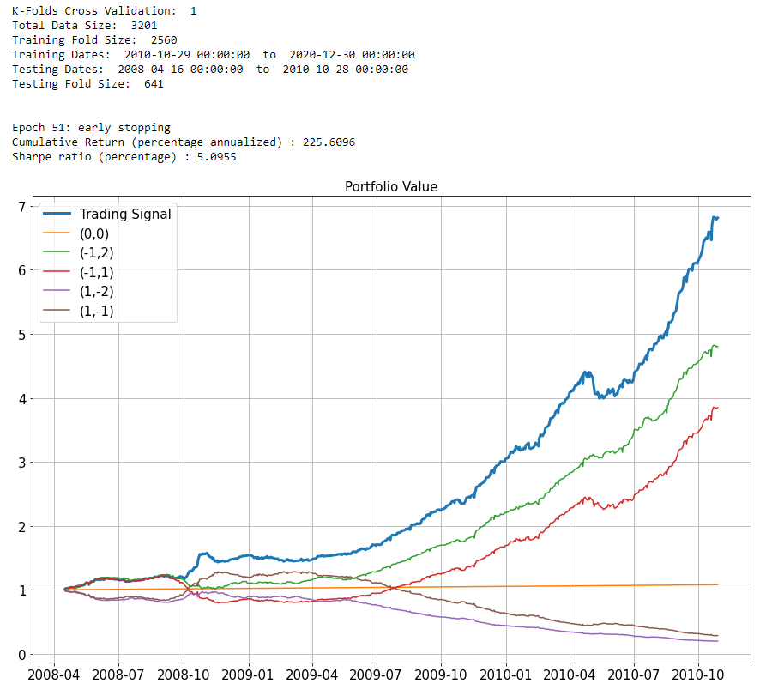

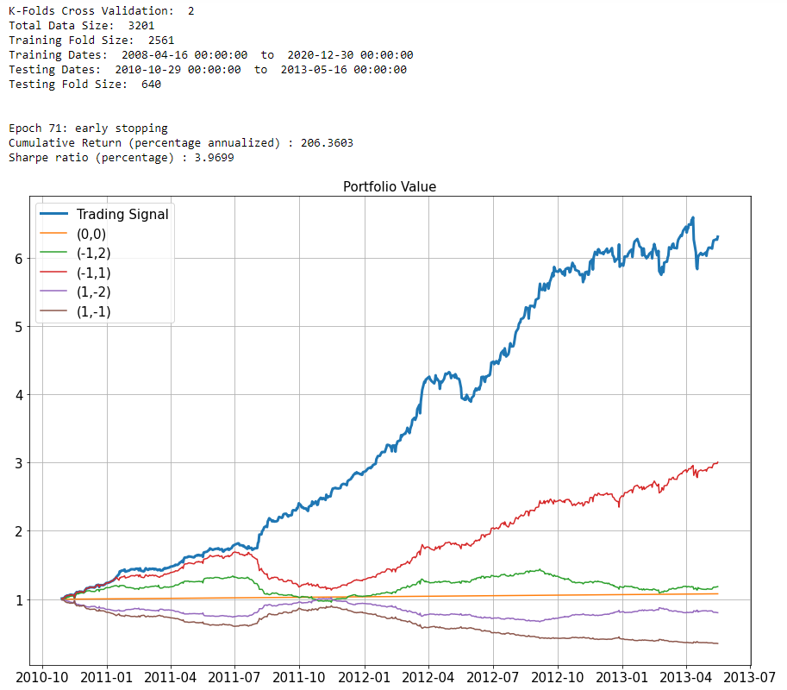

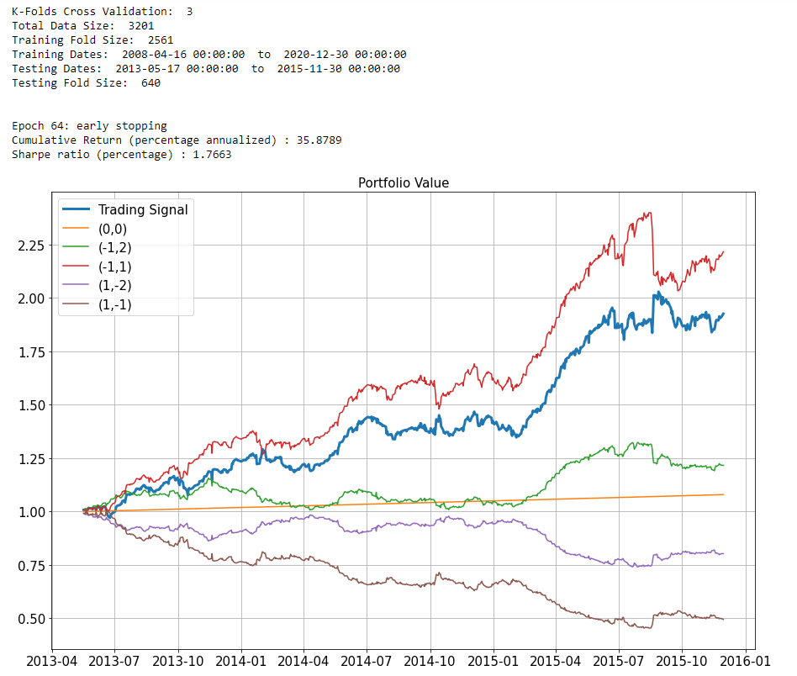

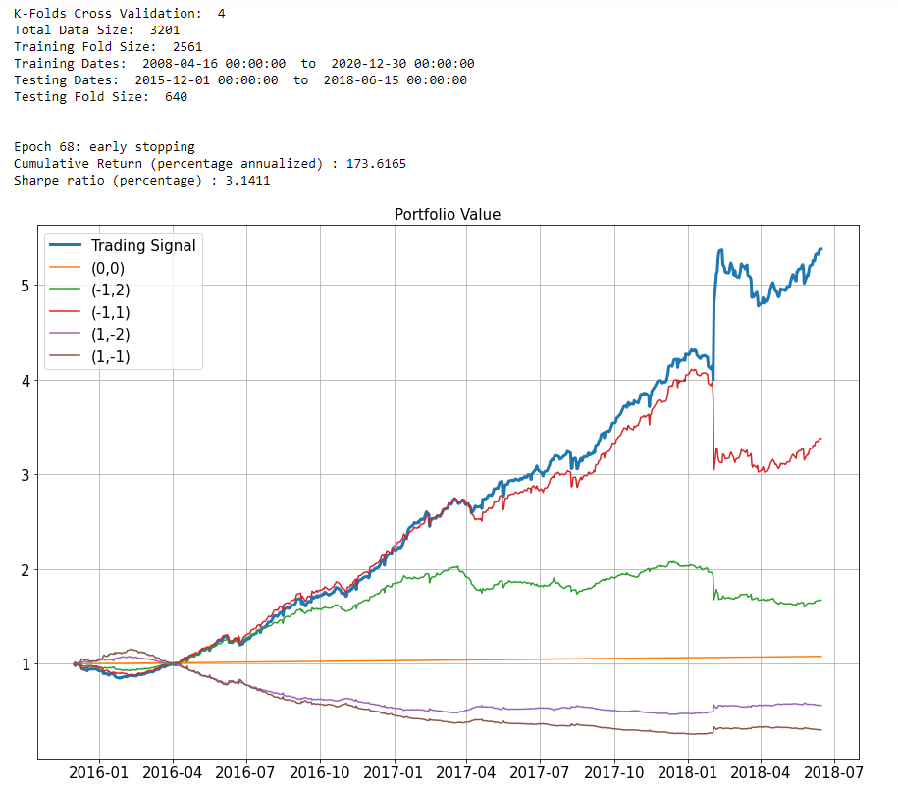

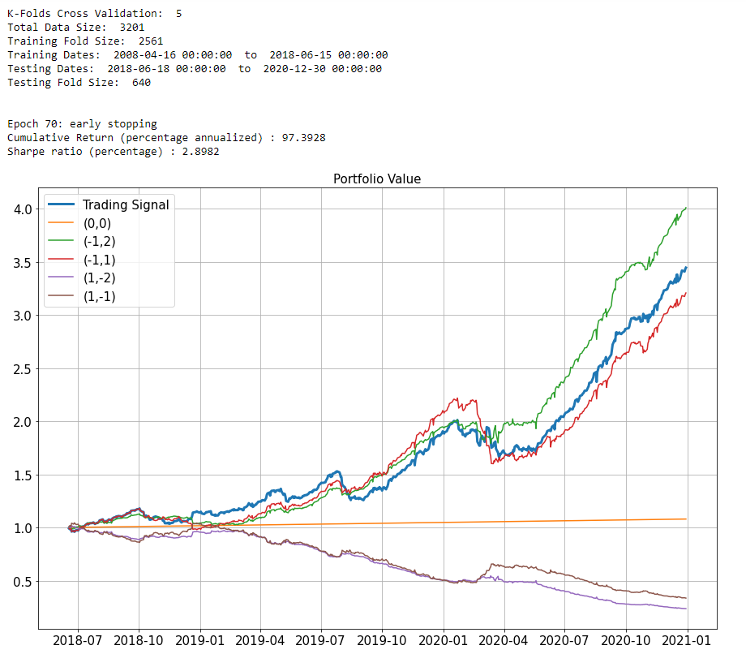

**\*\*\* As the conclusion of problem #2, based on these cross validations, I think the lookback method provide higher improved performance in comparison to the trading signal without lookback. Due to the graphs of above, with lookback window of 5 days, we can see our trading signal has higher cumulative return than other trading strategy in all folds. However, without lookback window, our trading signal lose in fold 3 and fold 5. It means the trading signal without lookback window don’t always have higher performance in all folds. Thus, based on these cross validations, I think the lookback method provide higher improved performance in comparison to the trading signal without lookback.**